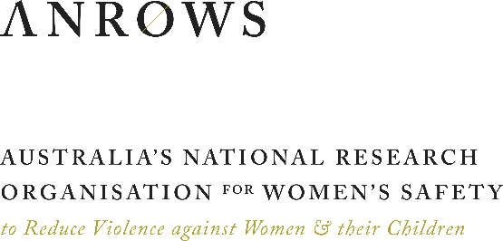
MEDIA RELEASE
TUESDAY 24 MARCH 2020

DOMESTIC VIOLENCE SCREENING FOR PREGNANT WOMEN
EVEN MORE IMPORTANT AS COVID-19 SPREADS

Incidents of domestic violence are likely to escalate in frequency and severity as coronavirus (COVID-19) spreads in the Australian community.
Research also shows that pregnancy is a risk factor for the onset and escalation of domestic violence. This means that pregnant women may now be at particularly high risk of violence from an intimate partner.
As health and social services struggle to respond to the virus, new research published today by Australia’s National Research Organisation for Women’s Safety (ANROWS) underscores the importance of maintaining and improving screening for domestic violence in antenatal care settings.
“It is critical that we ensure effective screening and response for domestic violence now, while COVID-19 presents a social stressor that may exacerbate the perpetration of abuse”, said Professor Kelsey Hegarty, lead researcher on the project and joint Chair in Family Violence Prevention at the University of Melbourne and the Royal Women's Hospital.
“Routine screening provides a crucial opportunity for early engagement with women to improve women’s safety and well-being.”
Sustainability of identification and response to domestic violence in antenatal care (the SUSTAIN Study) provides an evidence base for ways to improve and sustain practices to identify and respond to domestic violence in complex healthcare settings.
The research draws on the experiences of women and practitioners in six antenatal hospital clinics across Victoria and New South Wales. Their responses emphasise the importance of building relationships with pregnant women during the screening process.
“You don’t want her to feel like you’re just there asking questions—you want her to feel like she’s being cared for and nurtured so that she can disclose information to you,” explained one midwife who participated in the study.
“How we related and engage with women is the key,” continues Professor Hegarty. “If we expect women to tell us sensitive information, we need to be open with them and show kindness and empathy in our responses.”
The report puts forward a framework for implementing effective screening, called the REAL Transformation Model. This model can be used in all Australian health settings to better implement sustainable domestic violence screening practices into their antenatal services.
This is important for those working in state-based health systems with mandatory antenatal domestic and family violence screening (such as NSW and Victoria), as well as in states and territories where screening is either partially implemented, or under consideration.
The project has also produced practical guidelines offering scripts for midwives, obstetricians, social workers and GPs who are providing services to pregnant women.

“This research offers an important evidence base for system change, as well as practical assistance for health workers,” said ANROWS CEO Dr Heather Nancarrow. “This support is critical at a time when health services are under incredible strain and women are particularly at risk.”

The work builds upon earlier ANROWS research, the Women’s Input into a Trauma-informed systems model of care in Health settings (the WITH study), which explored the implementation of trauma-informed care in hospital mental health systems.

For further information, contact Michele Robinson at ANROWS
on +61 0417 780 556 or email michele.robinson@anrows.org.au.

About ANROWS
Australia’s National Research Organisation for Women’s Safety Limited (ANROWS) is a not-for-profit independent national research organisation.
ANROWS is an initiative of Australia’s National Plan to Reduce Violence against Women and their Children 2010–2022. ANROWS was established by the Commonwealth and all state and territory governments of Australia to produce, disseminate and assist in applying evidence for policy and practice addressing violence against women and their children.
ANROWS is the only such research organisation in Australia.

